ZAPIER AUTOMATION RECIPES

ABOUT THIS RESOURCE

Once you have watched the automation training video, use this resource to setup the automation recipes within Zapier. Triggers and recipe steps are provided as well as screenshots of all text and content that you will need to setup to complete your automations.

AUTOMATIONS FOR YOUR AGENCY
- INTERNAL JOB ASSIGNMENT & CREATIVE BRIEF DELIVERY
- CLIENT REQUESTS

AUTOMATIONS FOR YOUR LIFE

- DAILY AND WEEKLY REVIEWS, RECAPS AND AGENDAS
- DAILY VALUE CALCULATOR

FOR YOUR AGENCY
INTERNAL JOB ASSIGNMENT & CREATIVE BRIEF DELIVERY (CREATIVE BRIEF FORM TEMPLATE)

These are the recipe triggers and steps:

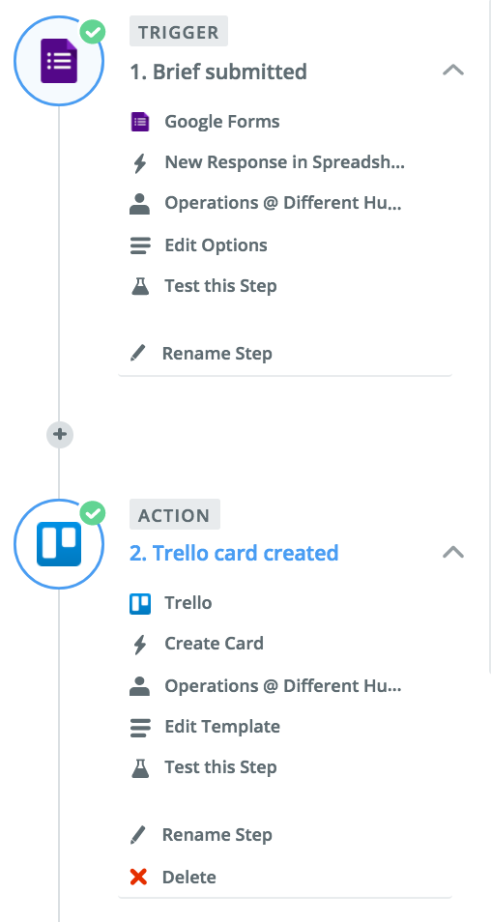 | 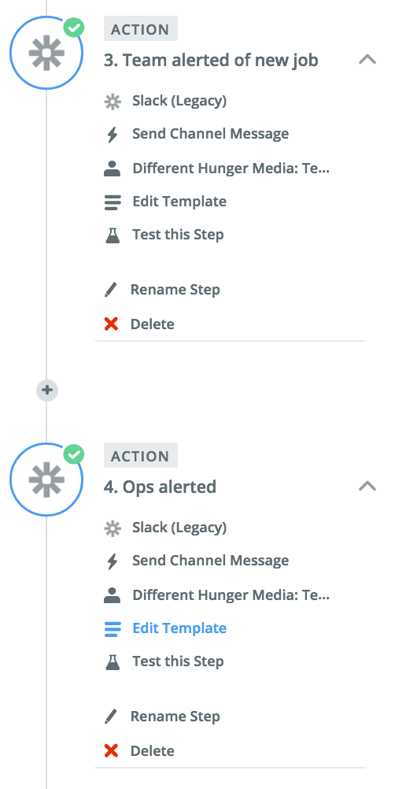

This is the Trello card setup:
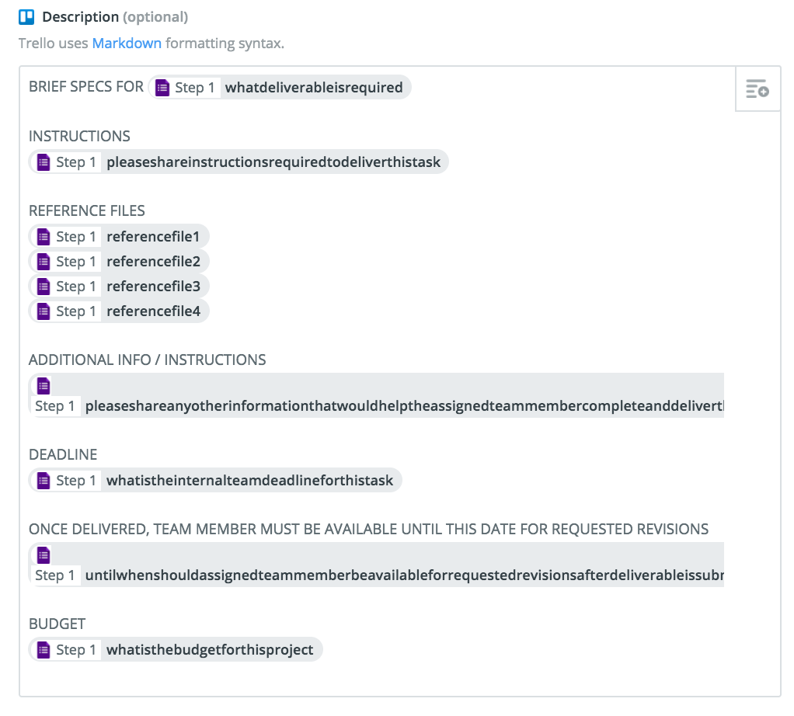
This is the Slack channel message setup (team):
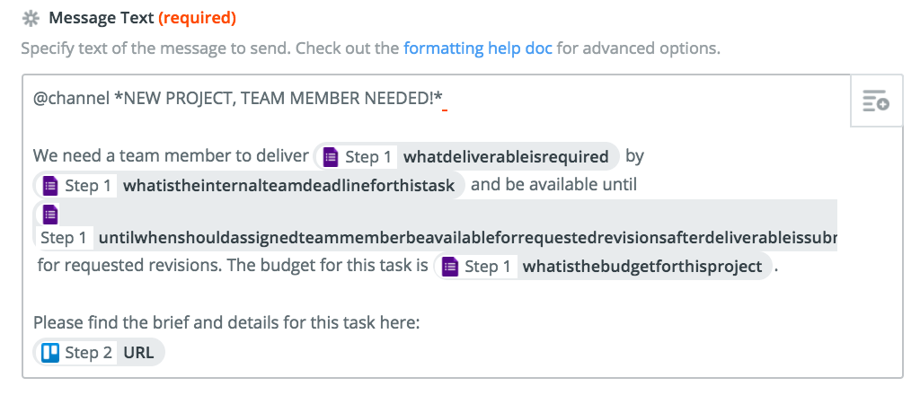
This is the Slack message setup (ops):
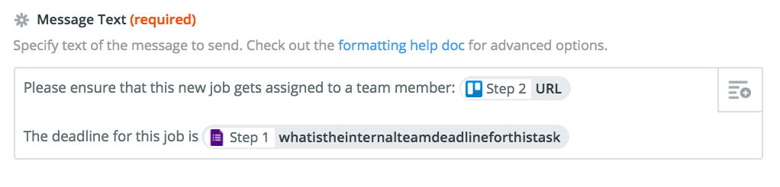

CLIENT REQUESTS AUTOMATION RECIPE (CLIENT REQUEST FORM TEMPLATE)

These are the recipe triggers and steps:
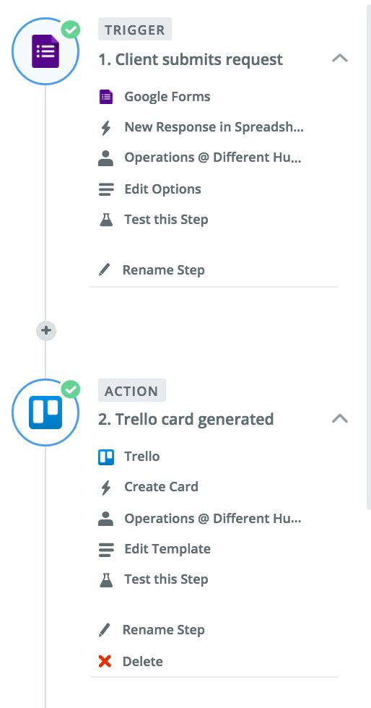 | 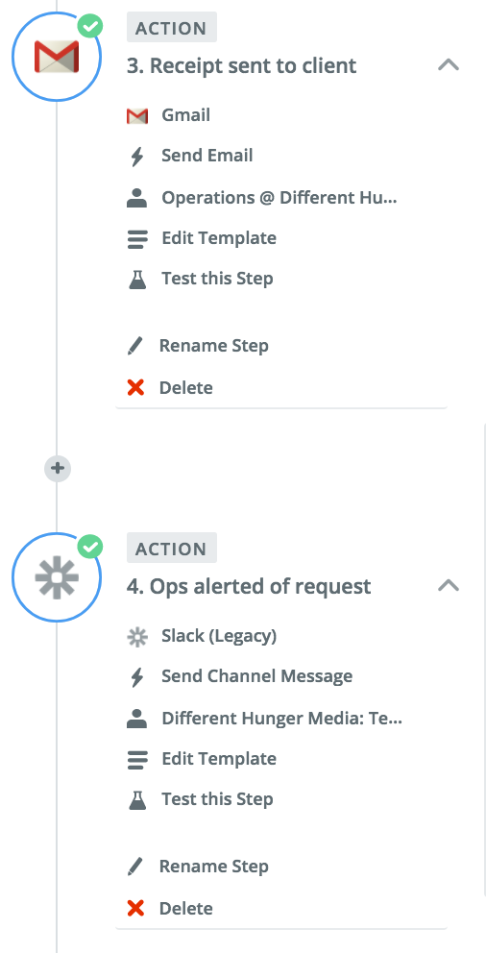
This is the Trello card setup:
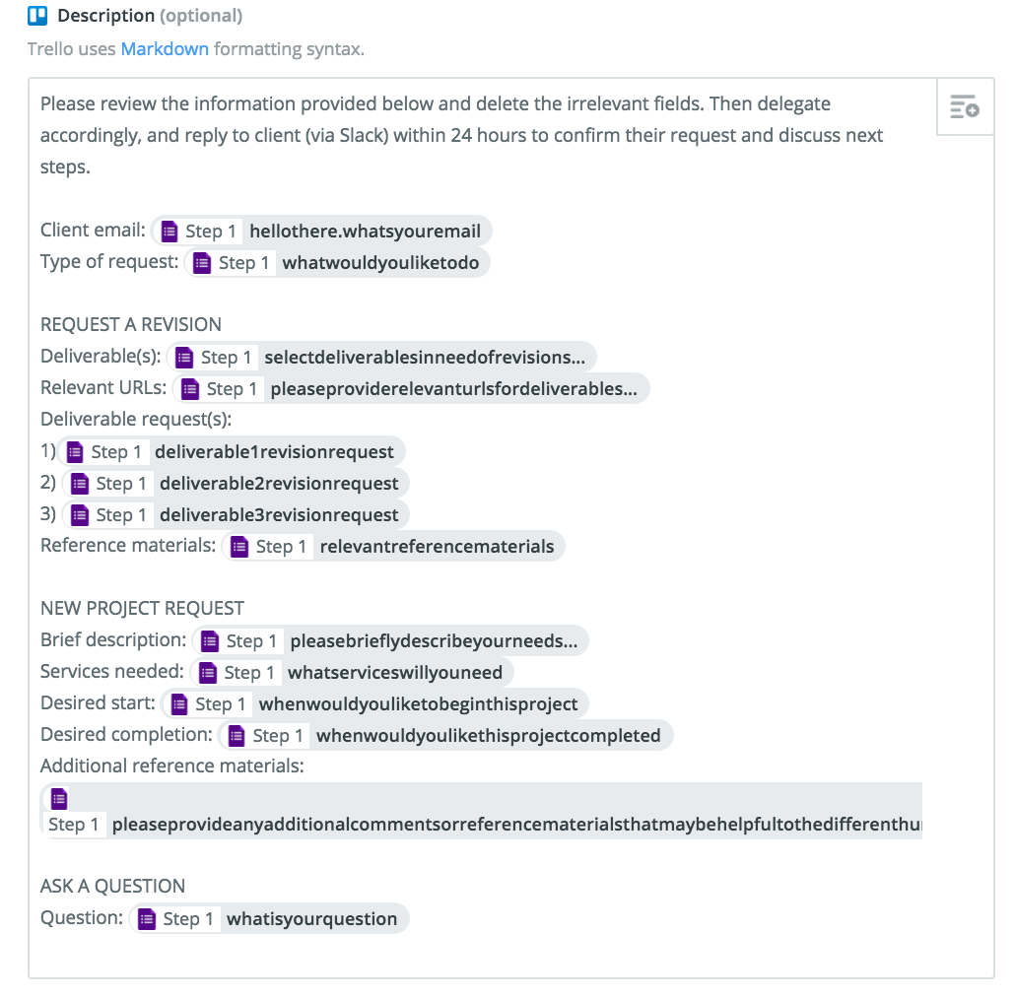

This is the client receipt email setup:
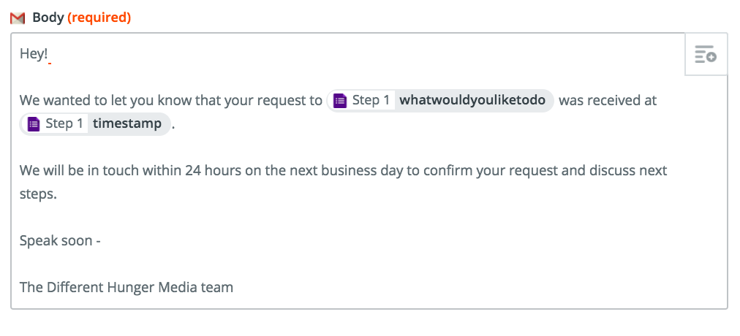
This is the Slack channel message setup:
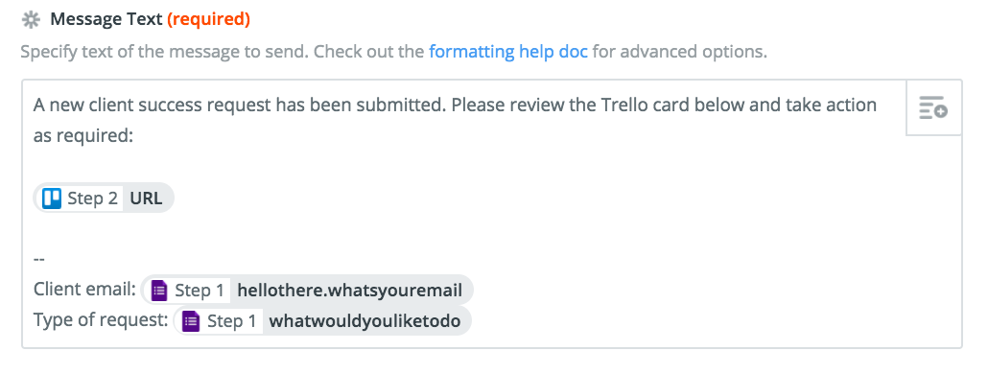
FOR YOUR LIFE

DAILY VALUE CALCULATOR AUTOMATION RECIPE (DAILY VALUE CALCULATOR TEMPLATE)

These are the recipe triggers and steps:
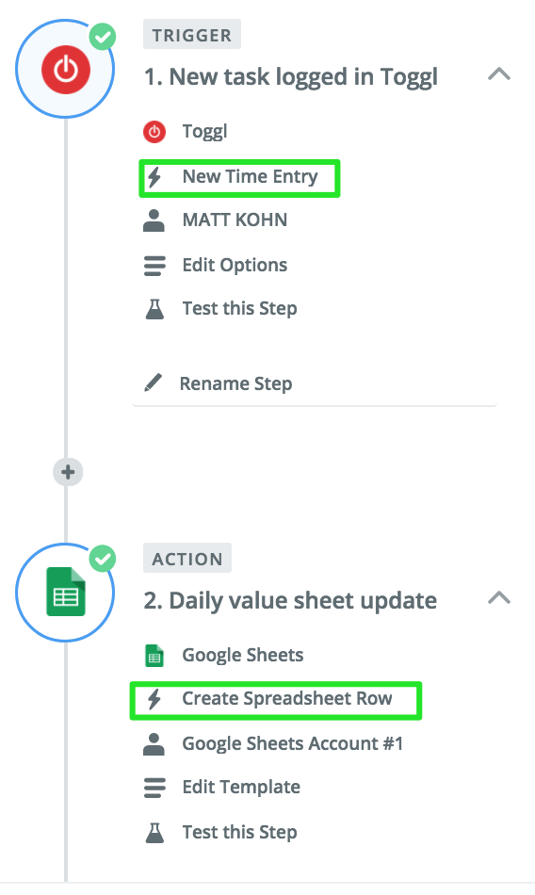

This is what gets updated on the daily value spreadsheet:

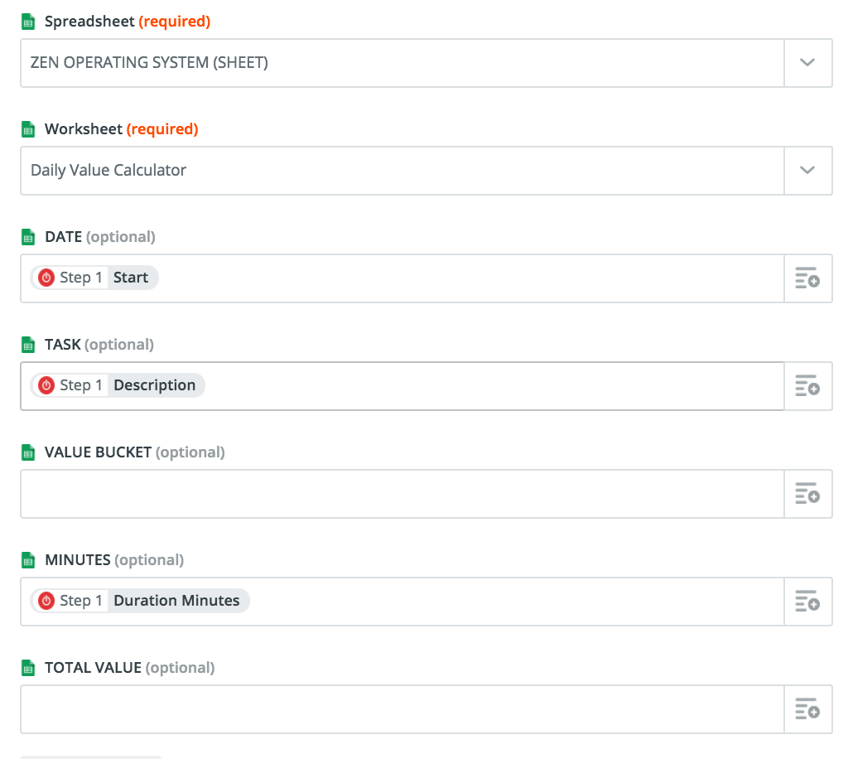

DAILY REVIEW RECAP & AGENDA RECIPE (DAILY REVIEW TEMPLATE)

These are the recipe triggers and steps:
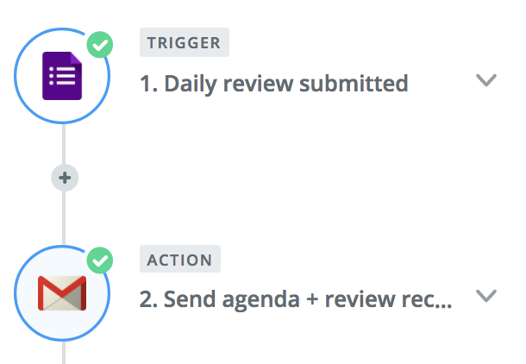

This is the structure of the automated email for the daily recap and agenda:
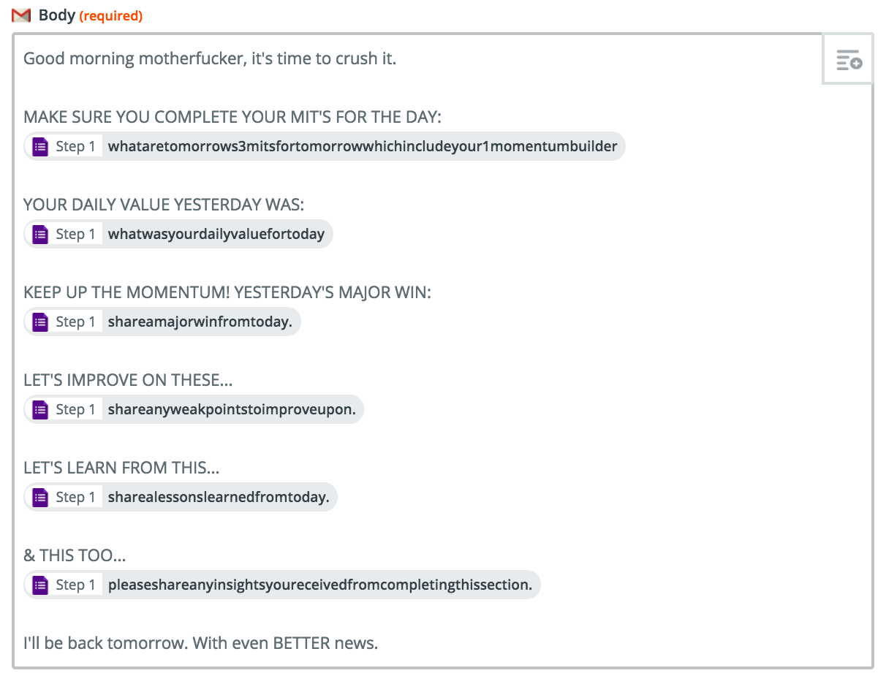

WEEKLY REVIEW RECAP & AGENDA RECIPE (WEEKLY REVIEW TEMPLATE)

The recipe trigger and steps are the same as the above daily review recipe, except the form you will be using as the trigger is the weekly review, not the daily review.

This is the structure of the automated email for the daily recap and agenda:
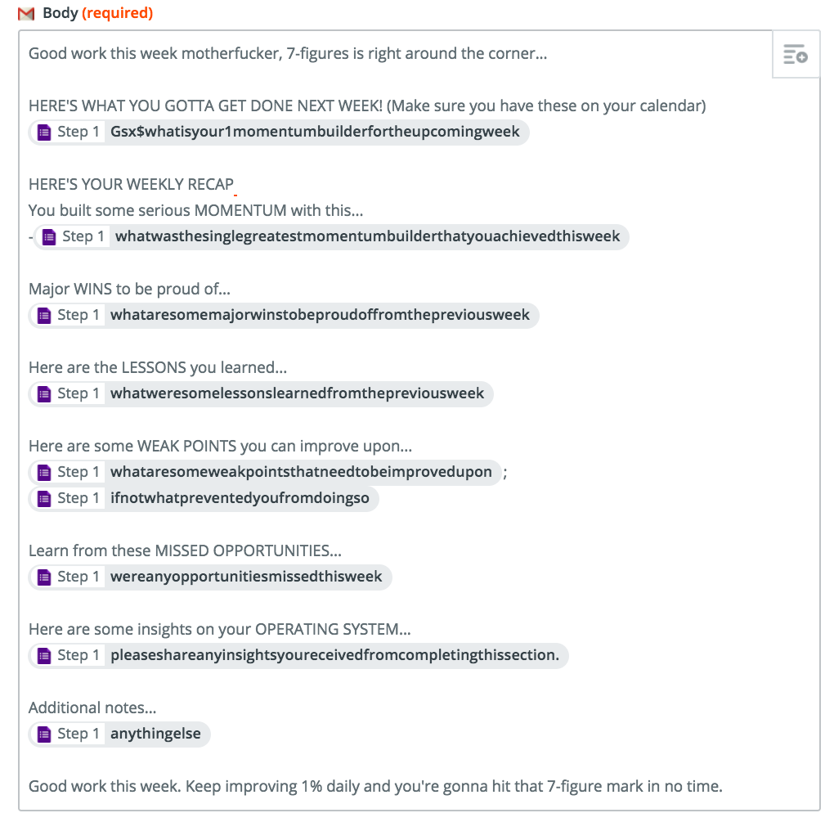

THE MOST IMPORTANT ASPECT OF THIS TRAINING IS THAT YOU BEGIN TO THINK SYSTEMATICALLY ABOUT EVERYTHING THAT YOU DO.

DOING SO WILL ALLOW YOU TO GO AHEAD AND CREATE MORE SYSTEMS AND AUTOMATIONS TO TURN YOUR MACHINE INTO VERSION 2.0, 3.0, ETC.

HAPPY HUSTLING.

