Plumb Quick – You’re Throwing Money In The Bin By Making These Critical Mistakes With Your Digital Marketing

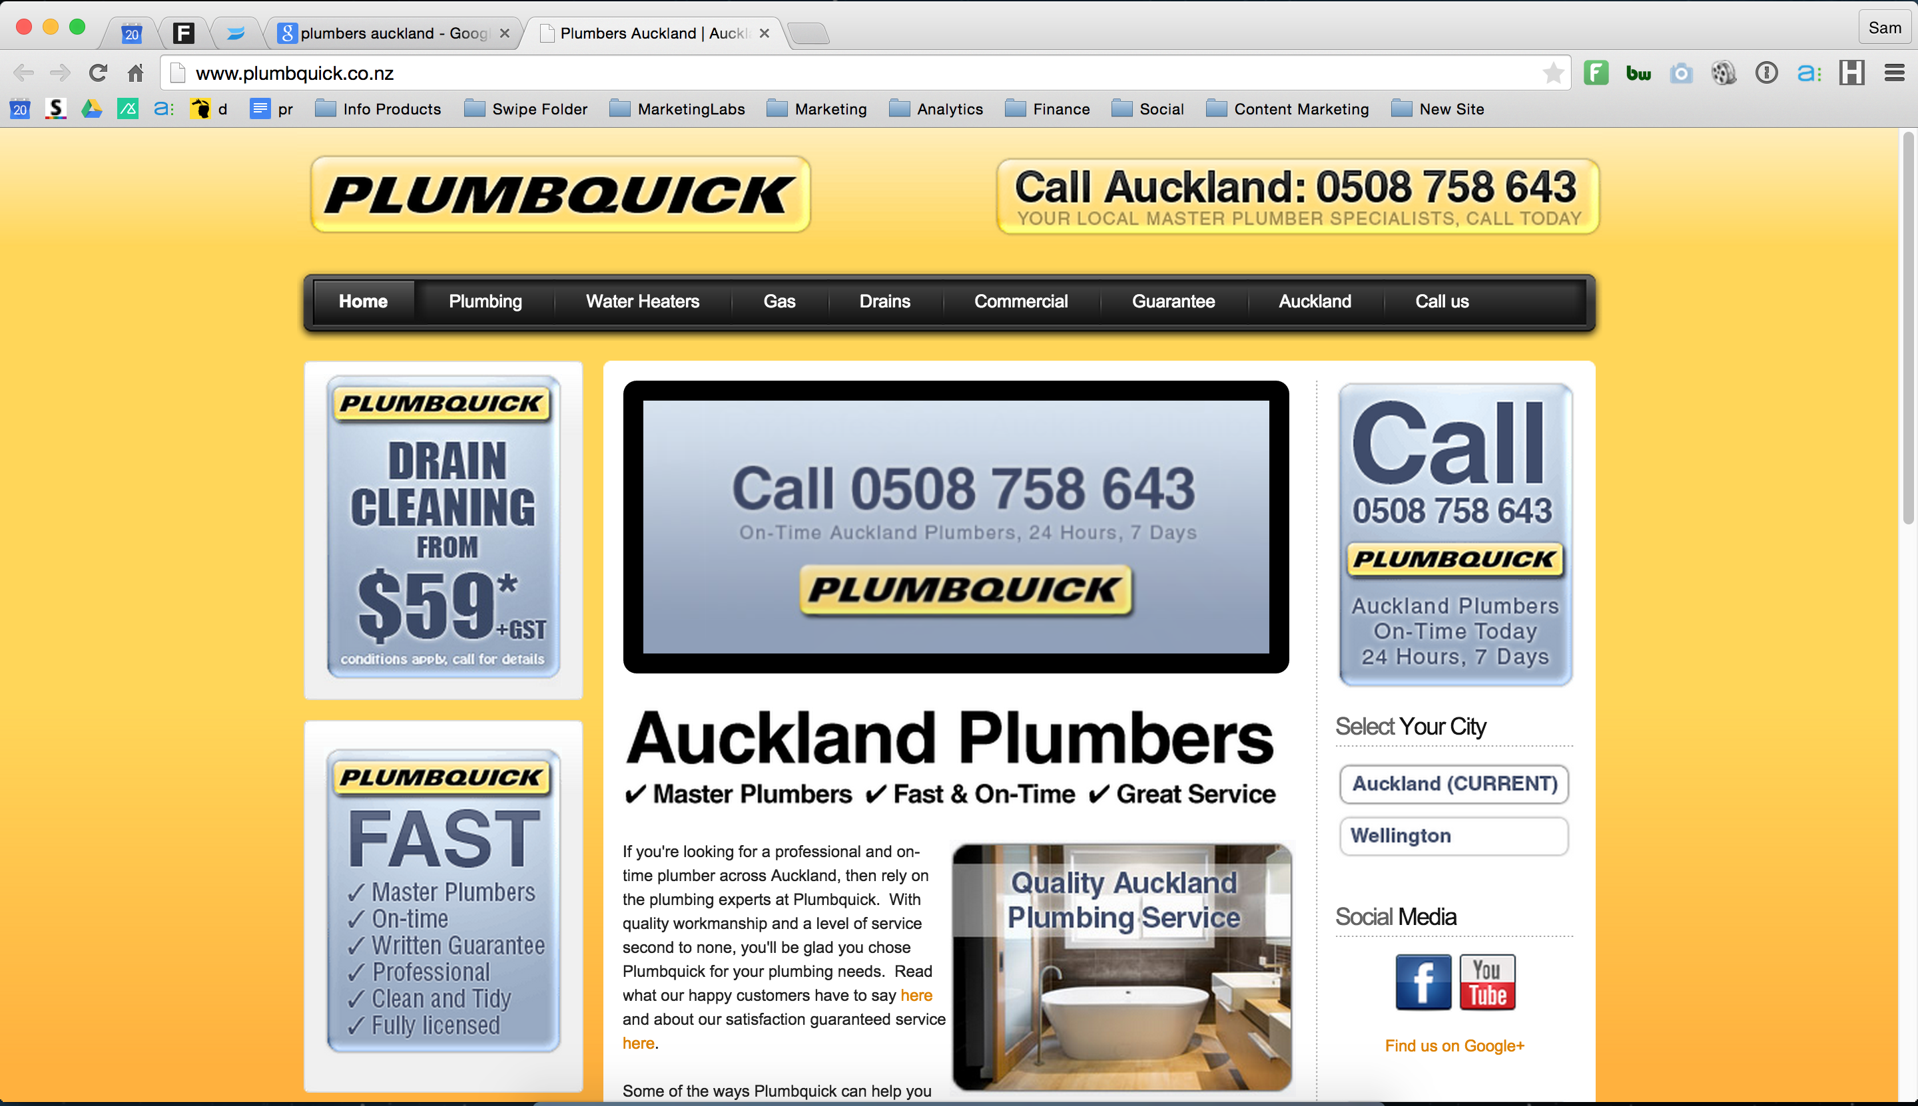

Plumb Quick, I visited your website through one of your Google Ad’s and noticed some critical mistakes that are costing you money and loosing you customers to the competition.

Making these mistakes is no different to actually throwing your money in the bin.

Turn the page and I will explain how…

Dear Plumb Quick,

Please forgive the forwardness of this letter but I can imagine as a business owner you would like to be told directly about things like this.

Right now you are spending money on Google Adwords and there are some critical mistakes with your campaign that are costing you money and loosing you customers to the competition.

Here’s The Problem:

Right now all of your advertising is driving traffic to your websites home page and this is one of the biggest “NO’s” in advertising.

People who search for a term like “Plumbers Auckland” click on an ad that says “Plumbers Auckland” and then they expect to land on a page that says “Plumbers Auckland” however you’re dropping them onto your home page…

When people land on this page they don’t get what they thought they were going to get and they hit the back button to go to the next offer which will be one of your competitors.

This is costing you money and you really need to fix this.

Here’s How To Fix This:

I have created a video just for you showing you in person the mistakes that you’re making and how you can fix them.

Jump onto your computer right now and go to this link:

[link goes here]

In this quick video I walk you through these mistakes and show you how to fix them so make sure that you go check it out now.

Your Name
Your Stormpiercer
Your Phone Number
Your Email

