Simon – People Looking For Your Services Are Going To Need More Than A Magnifying Glass To Find Your Business...

Simon,

Last month 43,600 people searched for terms like “Plumbers Auckland” in Google and you were no place to be found.

Here’s what the search results look like right now:

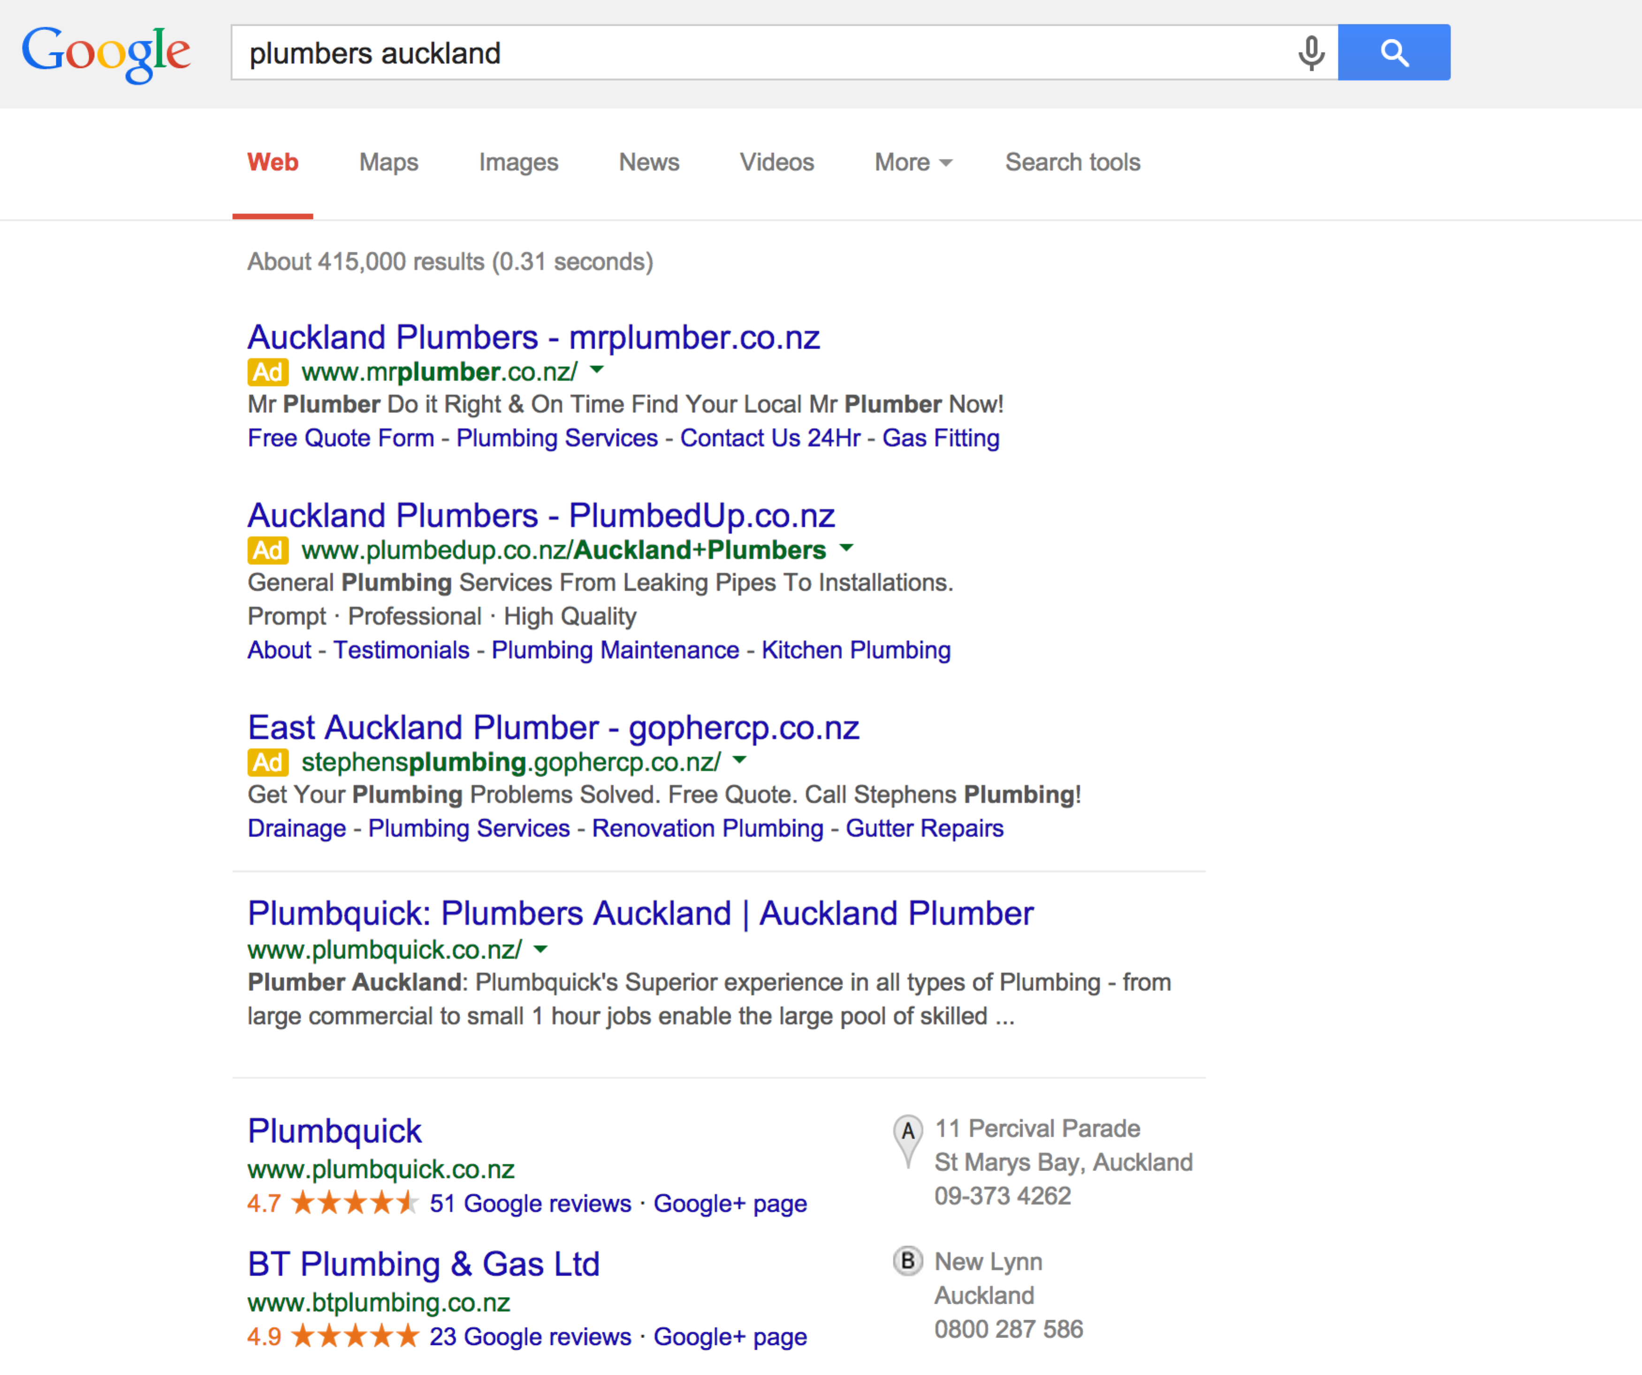

As I said… Even with a magnifying glass your business can’t be found…

Dear Simon,

Please forgive the forwardness of this letter but I can imagine as a business owner you would like to be told directly about things like this.

You see last month, over 43,600 people searched for terms like “Plumbers Auckland” online, these are people who have a problem and are in need of your services – they’re literally hot and ready to buy but…

Here’s The Problem:

Your business doesn’t appear anywhere for these search terms.

Look at the screenshot on the front page, your business is nowhere to be found.

That means that all of this business and all of this money is going to your competitors and you’re missing out big time.

But It Doesn’t Have To Be This Way:

There are ways to get your business on page one of Google immediately and in front of all of these searching customers.

I’ve had a look at the competition and I’m confident that we can get you results fast. Results that get your business appearing up the top of Google and results that get your phone ringing with ready to buy customers.

Here’s What I Recommend:

I’d like to offer you a free consultation where I’ll walk you through exactly what to do to get your business appearing in Google immediately.

I’ll outline all the necessary steps and at the end of this consultation you can take this information away and implement it yourself or hire somebody else to implement it for you – there are absolutely no obligations to choose me or my services unless you choose to.

To book a consultation please call [your phone] or email [your email].

Thanks!

-Your Name
Your Stormpiercer

